@FunctionalInterface

**interface** MyFunctionalInterface2 {

**public** **int** add(**int** i, **int** j);

}

If we want to indicate an interface as functional interface, we can annotate it with “@FunctionalInterface”.

Why we need that annotation?

Because compiler throws the error at compile time, if there are more than one abstract method.

We can compile time error

Multiple abstract methods

@FunctionalInterface

interface MyFunctionalInterface {

public int add(int i, int j);

public int sub(int i, int j);

}

MyFunctionalInterface.java:1: error: Unexpected @FunctionalInterface annotation

@FunctionalInterface

^

MyFunctionalInterface is not a functional interface

multiple non-overriding abstract methods found in interface MyFunctionalInterface

1 error

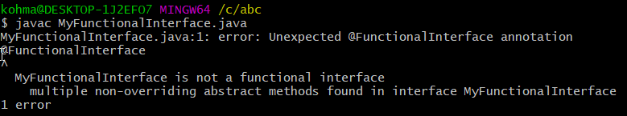

No abstract methods

@FunctionalInterface

interface MyFunctionalInterface {

}

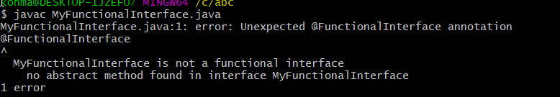

$ javac MyFunctionalInterface.java

MyFunctionalInterface.java:1: error: Unexpected @FunctionalInterface annotation

@FunctionalInterface

^

MyFunctionalInterface is not a functional interface

no abstract method found in interface MyFunctionalInterface

1 error